**MESD LMS Documentation – Collaborating through Q&As, forums and messaging**

**Purpose**

To facilitate with asking and answering questions on the Q&A module, How to post topics, reply to posts and subscribe for notifications using forums, and activating the messaging system.

**Background**

This module handles requests directly from Learnerswithin the Moodle system, allowing collaboration through Q&As, forums and messaging.

**Usage**

**To use messaging**

1. Log in as a Leaner user.
2. To send a message, click on the message icon in the navigation bar, then select the recipient you want to send the message to.

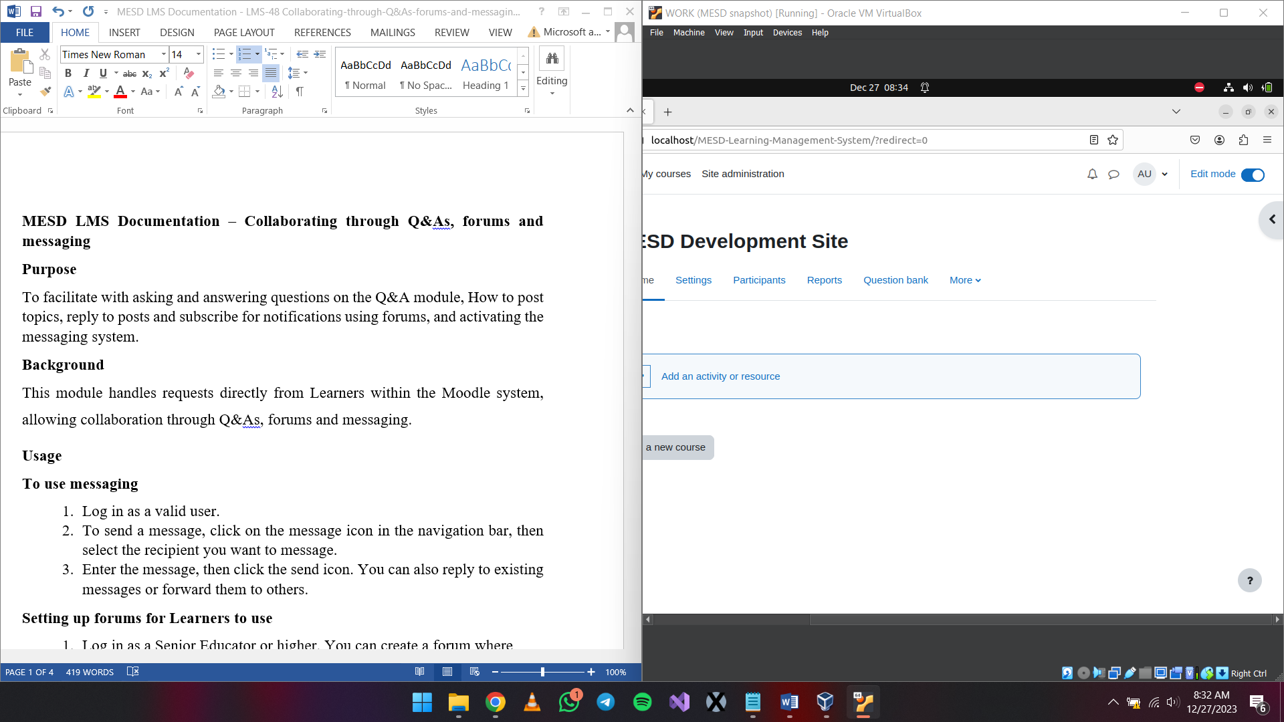

1. Enter the message, then click the send icon. You can also reply to existing messages or forward them to others.

**Setting up forums for Learners to use**

1. Log in as a Senior Educator or higher.
2. Select the *‘Edit mode’* toggle in the upper right.
3. Choose course where you want to add the forum and select *‘Add an activity or resource’.*

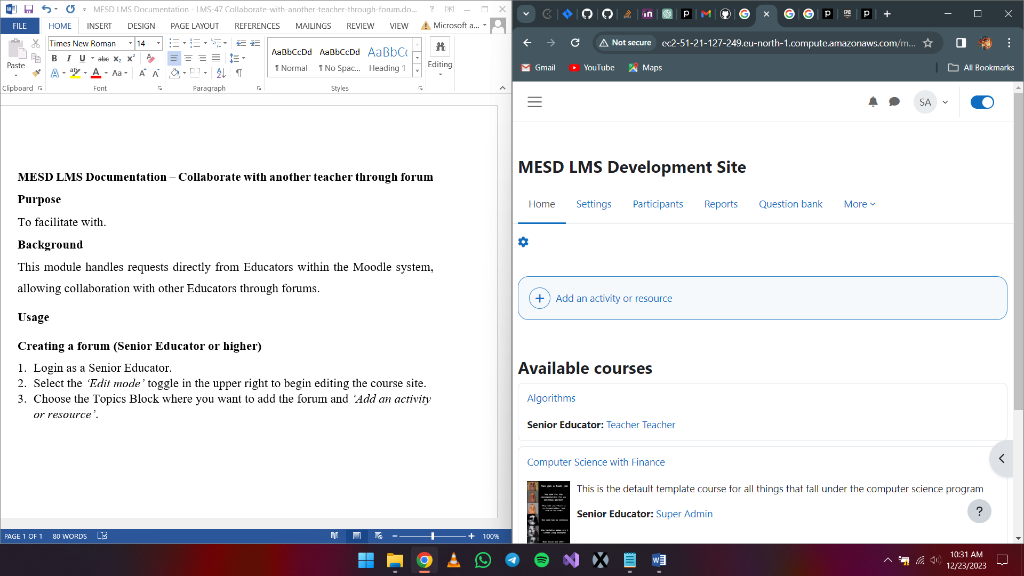



1. Choose forum.

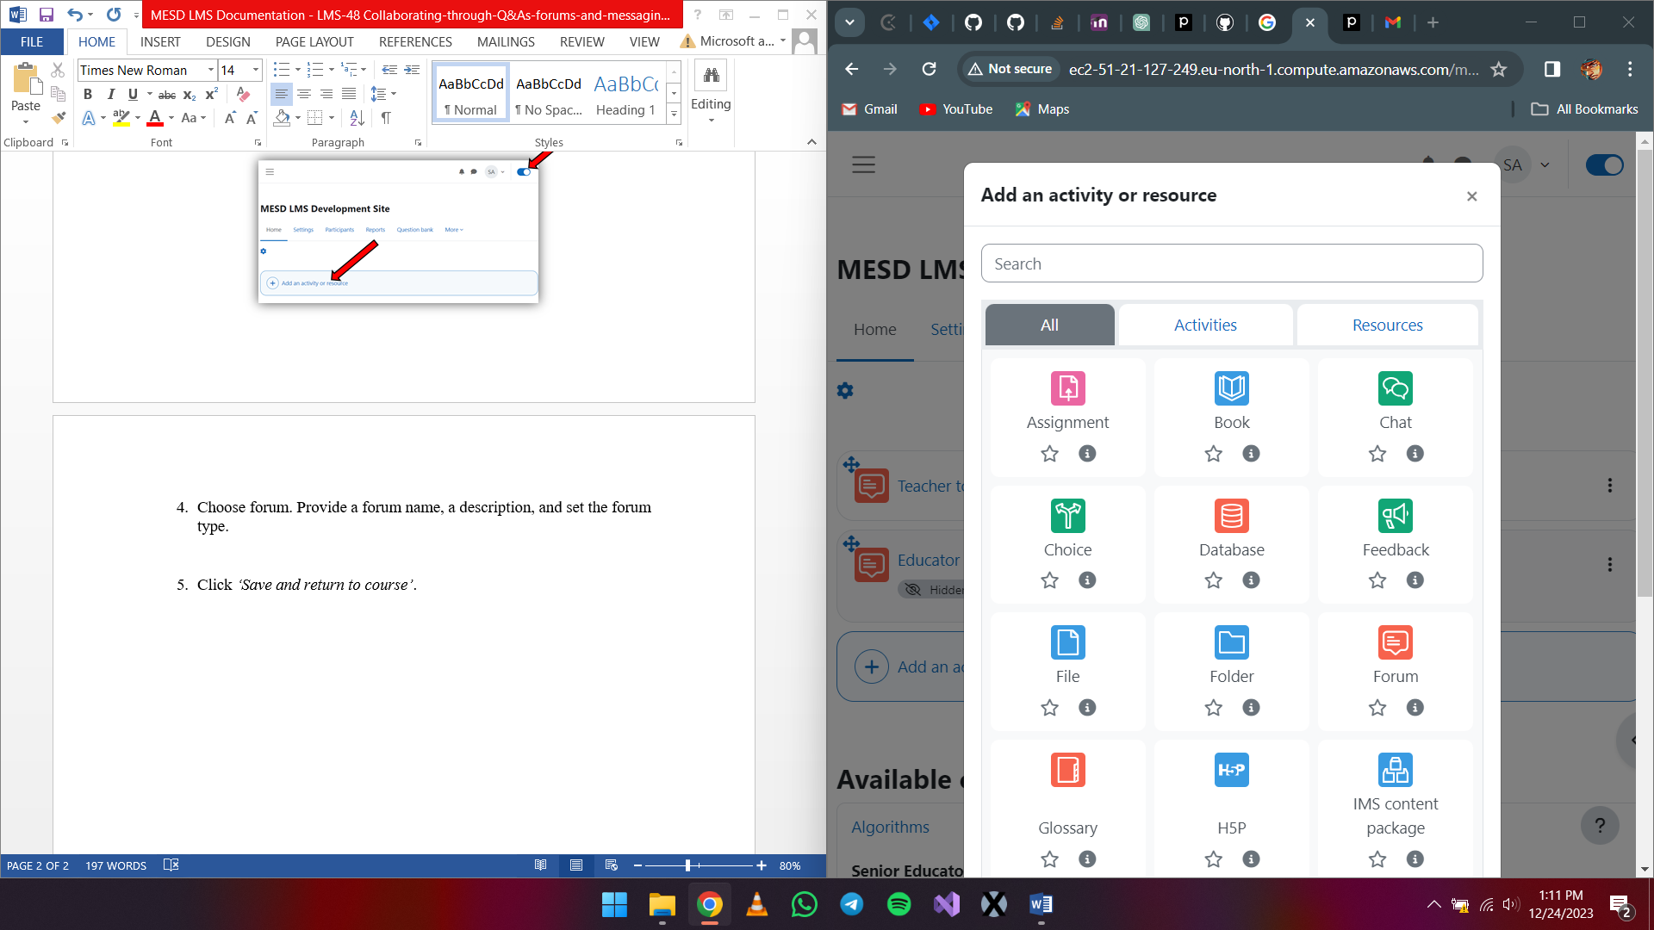

1. Provide a forum name, a description, and set the forum type.
2. Click *‘Save and return to course’*.

**Availability and assigning roles**

1. After creating the forum, while in edit mode, click the three dots to view options for that forum.

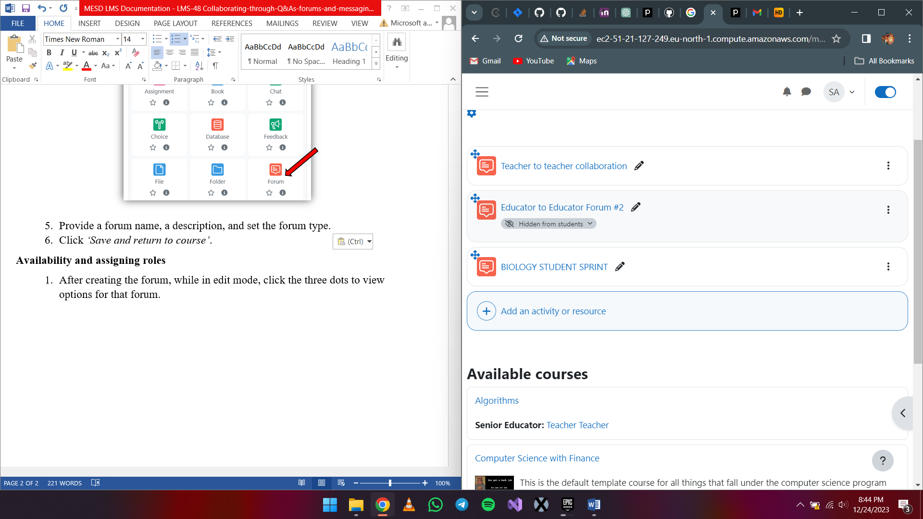

1. Availability
   1. Click on *‘Availability’* and set whether to make this forum available for everyone to see or not.

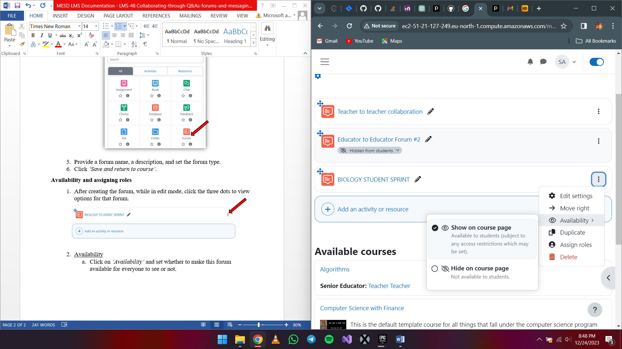

1. Assigning Roles
   1. Click on *‘Edit settings’* > *‘Subscriptions’*. Select *‘Manage subscribers’* under the View subscribers dropdown. Select the participants you want to add then click on *‘Add’*.

**Using the forum/QnA forum**

1. Login as a Learner
2. Select the QnA forum to open it
3. Adding a discussion topic
   1. Click on *‘Add discussion topic’*.
   2. Fill in details about the subject and message. When done click *‘Post to forum’*.
4. Deleting a post in a forum
   1. Click the post you created.
   2. Click on the *‘Delete’* button.
   3. When the prompt appears select *‘Continue’*.
5. Editing a post in a forum
   1. Click on the post.
   2. Select *‘Edit’*.
6. Replying to a post in a forum
   1. Click on the post you want to reply to.
   2. Choose *‘Reply’*.
   3. When you get the reply box, enter your message then select ‘Post to forum’ or cancel to end the operation. You can optionally choose to respond privately by ticking the Reply privately box.

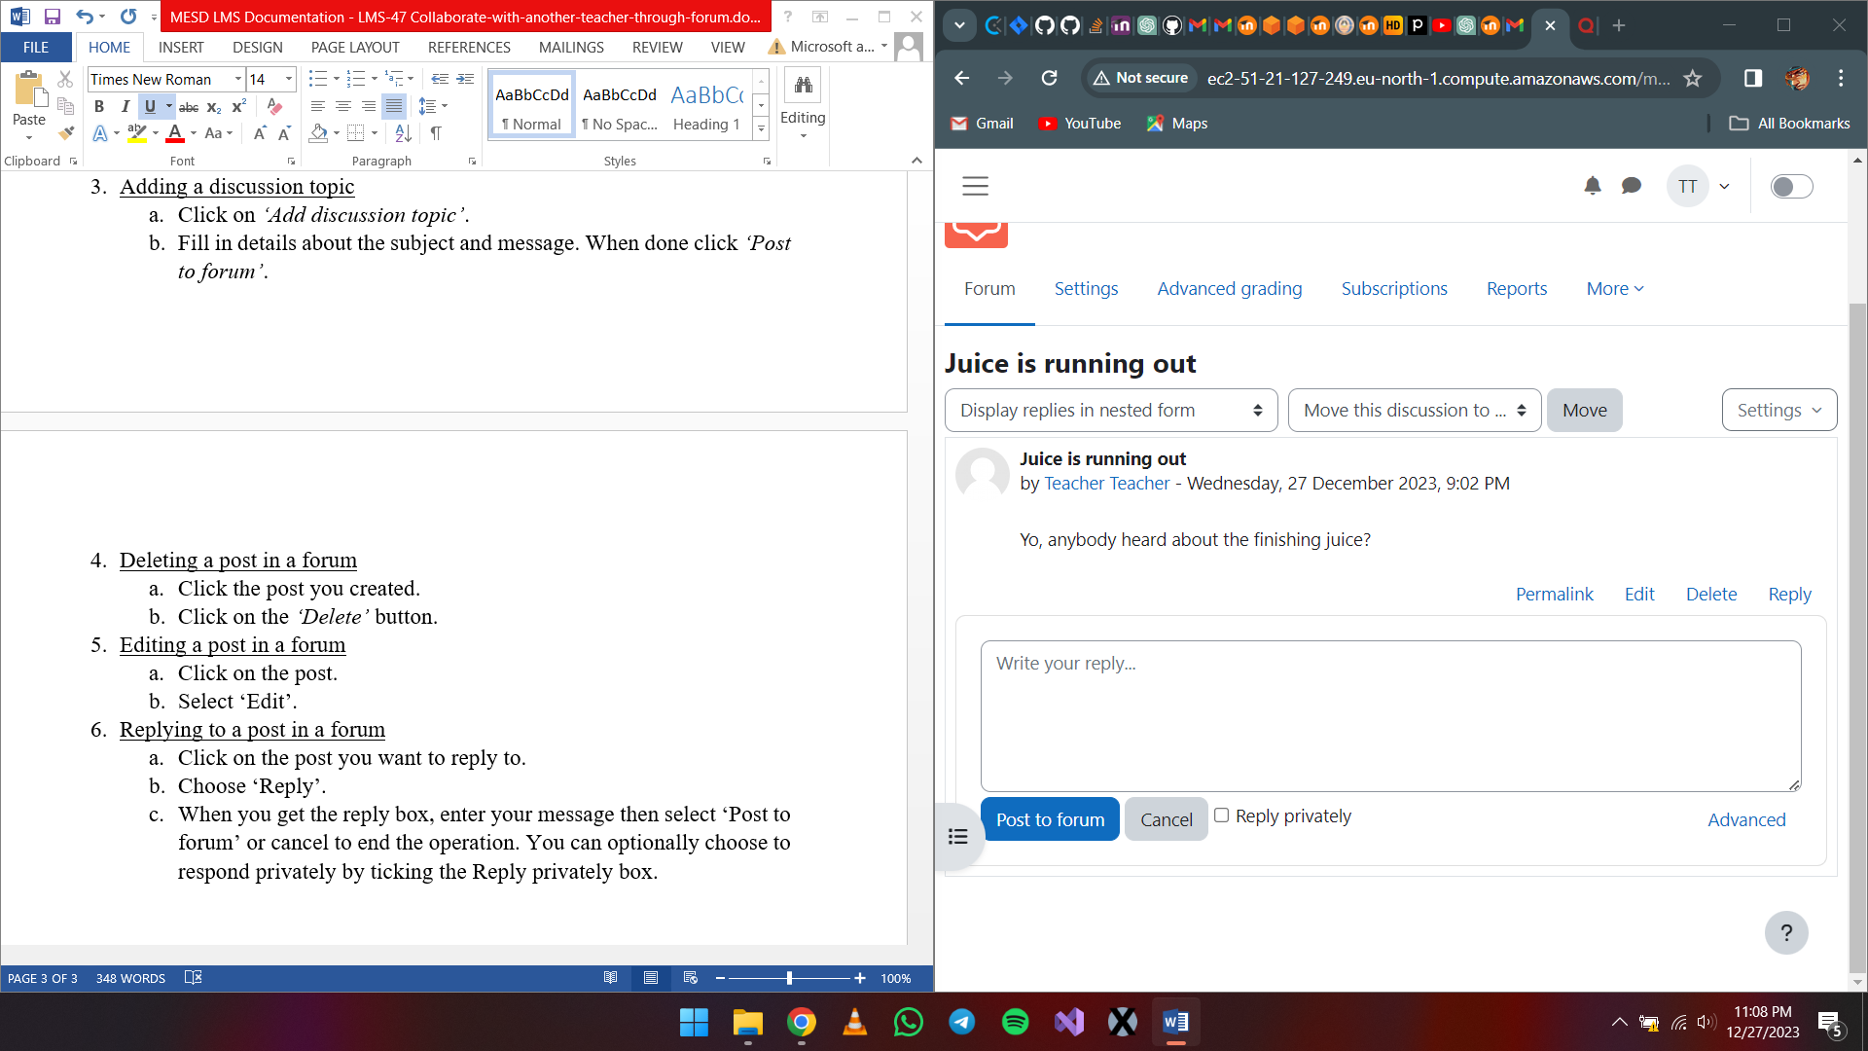

**Creating the Q&As**

To create a Question and Answer environment you can set up a forum where only the Educator can start discussions, but the students can only reply. Each thread you start contains a question or a task, and the students make a plan or answer the question and post it as a reply.

1. Set up a forum for Q&A. Follow the steps above on how to create a forum.